CONTENT
Introduction 2
1.1 Contributions 2
1.2 Organization 3
2 Background 4
3 Off-line model generation 5
3.1.1 Calculation of conditional probabilities 5
3.1.2 Priori probabilities 6
3.2 On-line model: prediction generation 7
4 Privacy analysis 9
Conclusion 10

Introduction

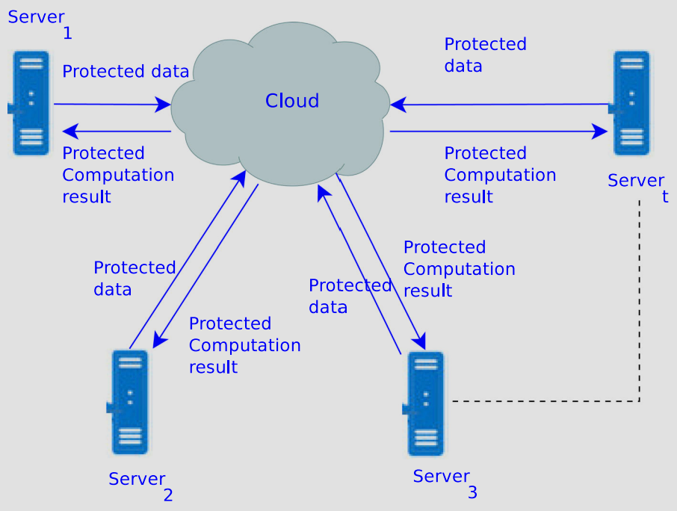
Fig. 1 – Privacy preserving classification on cloud
If the organizations are assured of privacy of their data, then they coordinate with each other for mining of their datasets. For the binary rating matrix, Naive Bayesian Classifier (NBC) can be used to anticipate the likeness of the user for an item. In literature, few studies have been proposed for privacy preserving recommendation generation for binary ratings based on NBC. These techniques were based upon data perturbation and homomorphic encryption techniques which cause the high computation costs and some accuracy loss. Therefore, in this paper, ClaMPP scheme based on NBC is proposed for generating the prediction on arbitrarily distributed binary data among different parties using the cloud environment having low computation costs and negligible accuracy loss. The system model of the proposed scheme is shown in Fig. 1.

Contributions
The main contributions of the ClaMPP are as follows.
- The PPCF scheme based on NBC classifier on cloud environment is proposed for ADD among multiple parties such that the parties from different regions can collaborate with each other efficiently.
- ClaMPP does not use data perturbation for privacy, so it has negligible accuracy loss.
- Four protocols are proposed in this work. Conditional probability between itemsis calculated using protocols I and II, while protocol III calculates the prior
- probability of item vectors and protocol IV generates the predictions.
- The proposed scheme is analysed using different evaluation parameters such as: security, accuracy and coverage. It has been experimentally demonstrated that accuracy and coverage of the proposed scheme are better in comparison with the other existing schemes.Заголовок 3

Organization

The paper is organized as follows. Related work is discussed in Sect. 2. In Sect. 3,
background and preliminaries are discussed. In Sect. 4, the proposed ClaMPP scheme
is discussed in detail. In Sect. 5, privacy analysis of the proposed scheme is elaborated.
In Sect. 6, experimental results are discussed using various performance evaluation
parameters which include security, accuracy and coverage. Finally, Sect. 7 concludes
the article.

Background
In some rating systems, users express their preferences about a product in binary form, i.e. they either like a product or dislike it. When factors affecting the classification results are conditionally independent, NBC is considered as one of the best classifiers. It can directly calculate the probability of user’s possible interests and calculation of similarity or distance metrics (e.g.Pearson correlation, cosine similarity and euclidean distance ) is not required, whereas in other algorithms such as k-NN there are many parameters which need to be determined manually. The class label of item l given its m feature values can be calculated using NBC as:where f₁, f₂.. fm represent the m features of item l, classy represents the class label of item l and the “naive” assumption is made that given the class label, features are independent of each other. Here, p(classj) represents the prior probability and p( fi|classj) represents the conditional probability which are calculated from training data. The class label of item l given its m feature values can be calculated using NBC as:
$$p\left(\left.{class}_{y}\right|f_{1},f_{2}..f_{m}\right)αp\left({class}_{y}\right)П_{i=1}^{m}p\left(\left.f_{i}\right|{class}_{j}\right)$$ | (1)
where $f_{1},f_{2}..f_{m}$ represent the m features of item l, classy represents the class label of item l and the “naive” assumption is made that given the class label, features are independent of each other. Here, p(classj) represents the prior probability and $p\left(\left.f_{i}\right|{class}_{j}\right)$ represents the conditional probability which are calculated from training data.

Off-line model generation
For generating off-line model, conditional probabilities p(r_{h}|C_{y}) and prior probabili#ties p(C_{y})should be calculated for all item vectors. Hence, the parties P₁, P₂, P₃.....P_{t} collaborate with each other off-line using cloud to compute these probabilities while maintaining privacy of their data. The privacy is ensured while calculating condi#tional probabilities by using an extended version of privacy preserving scalar product protocol based on random masking and polynomial aggregation technique. Homomorphic encryption technique is used for ensuring the privacy while calculating prior probabilities. Additive property of homomorphic encryption is used since only the secure sum is required . The comparative analysis of different methods for calculating the secure sum is provided in Table 3. As seen in Table 3, the communication cost of secret sharing scheme is quite high as compared to homomorphic encryption whereas, for data perturbation scheme, fault tolerance is zero and parties need to be connected in some topology (e.g. ring). Due to all these issues, homomorphic encryption technique has been used in our proposed work.
Table 1 – Comparison of schemes for calculating secure sum
Scheme | Computation complexity | Communication complexity | Fault tolerance | Security | Topology required
Secret sharing | Low | High | Yes | High | No
Paillier | High | Low | Yes | High | No
Paillier | Low | Low | No | High | Yes

Calculation of conditional probabilities
Since the user can ask prediction for any item, a model is required which considers all possible rating (1 and 0) for all items. Let’s consider that a user u wants prediction for iteml elonging to the set of items m. Assume that K and L represent the rating vectors for an item k and a target item l, respectively. Since data are arbitrarily partitioned among multiple parties so $K=\left(K_{P_{1}}\left\|K_{P_{2}}\right\|...K_{P_{t}}\right)$ and $L=\left(L_{P_{1}}\left\|L_{P_{2}}\right\|...L_{P_{t}}\right)$, where $K_{p_{i}}$ is rating vector for item k held by party $P_{i}$ and $L_{p_{i}}$ is rating vector of item l held by $P_{i}$. It is assumed that there are no overlapped ratings among different parties, i.e. $K_{p_{1}}∩K_{p_{2}}∩K_{p_{3}}...∩K_{p_{t}}=∅$ and $L_{p_{1}}∩L_{p_{2}}∩L_{p_{3}}...∩L_{p_{t}}=∅$. For any rating rk , conditional probability is computed as:
$$P\left(\left.r_{k}\right|C_{y}\right)=\frac{μ}{δ}=\frac{\sum_{i=1}^{t}{\sum_{j=1}^{t}{{μp}_{i}}}p_{j}}{\sum_{i=1}^{t}{\sum_{j=1}^{t}{{δp}_{i}}}p_{j}}$$ | (2)
where $μp_{i}p_{j}$ is the number of users who rated items k and l which are held by party $p_{i}$ and $p_{j}$ , respectively, and the ratings for item k is same as rk of user u; having class label Cy . Let $δp_{i}p_{j}$ be the number of users who rated both k and l; have a class label Cy and ratings of k and l are held by party $p_{i}$ and $p_{j}$, respectively. Since binary ratings are considered, parties need to evaluate $P\left(\left.r_{k}\right|C_{y}\right)$ for four cases ($r_{k}=0$, $r_{k}=1$, $C_{dislike}=0$ and $C_{like}=1$). In Eq. 2 for i = j, the components which are owned by same party i.e., $μp_{1}p_{1}$, $μp_{2}p_{2}$ ..., $μp_{t}p_{t}$ and $δp_{1}p_{1}$, $δp_{2}p_{2}$ …,$δp_{t}p_{t}$, are calculated by respective parties ($P_{1}P_{2}...P_{t}$) independently. However, for $i≠j$ the cross-wide components $μP_{i},P_{j}$ and $δP_{i},P_{j}$ are calculated by the collaboration of different parties. For calculating μ and δ securely, two protocols, namely protocol I and protocol II have been proposed. The parties are divided into two sets M P called the master party and C P, the collaborating parties where M P contains only one party and C P contains other parties who, by collaborating with M P, help in calculation of μ.

Priori probabilities
Priori probability is calculated by finding the probability of selecting a rating having class Cy from all ratings of item vector L. Since the data are arbitrarily distributed among multiple parties, it can be calculated as follows:
$$P\left(C_{y}\right)=\frac{C_{y,L}}{\left|L\right|}=\sum_{i=1}^{t}{\frac{C_{y,L}}{\left|L\right|}}$$ | (3)

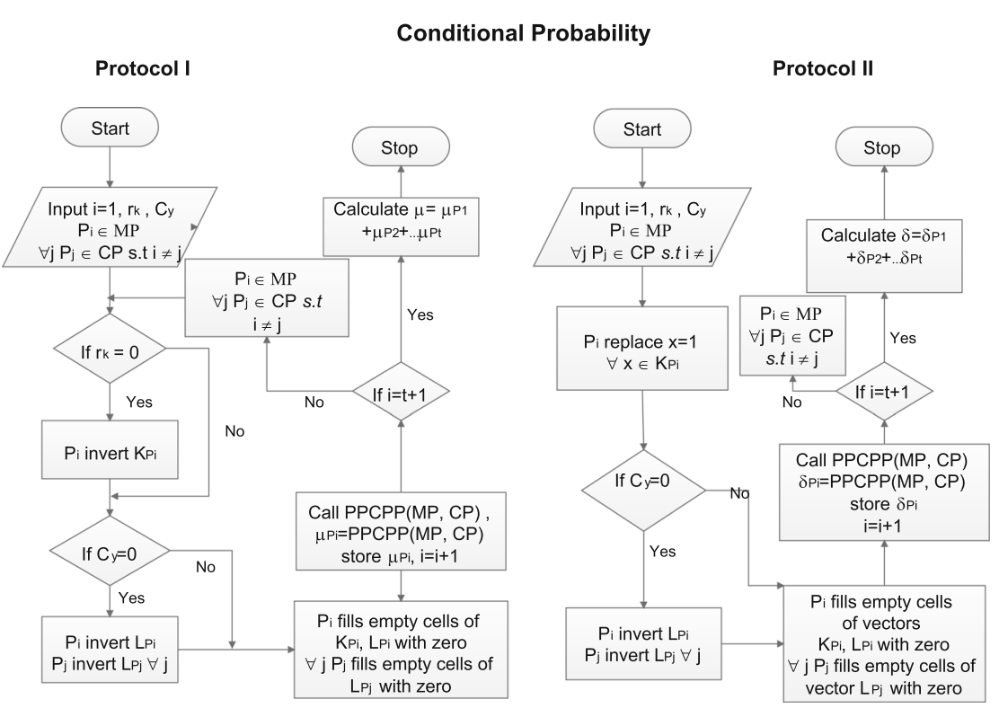
Fig. 2 – Flowchart for calculation of conditional probabilities

On-line model: prediction generation
The recommendation for user u for item l is generated by using off-line model discussed in the previous Sect. 4.1. In this process, one party act as an Active Party (AP) which interacts with user u. Let P₁ is A P and u’s ratings are distributed among different parties and mPi denotes the number of ratings held by party P_{i} . Thus, AP has to calculate probabilities for both classes with collaboration of other parties and assign the item l to class having higher probability. The steps for on-line prediction generation with collaboration of all parties in a secure manner are discussed in Protocol IV. The flow diagram for the same is provided in Fig. 1.
Protocol IV: Prediction Generation
- Party AP informs other parties$P_{j}∈OP∀j$ through cloud about l.
- Party AP computes${res}_{i_{y}}=П_{i=1}^{M_{AP}}p\left(\left.r_{i}\right|Cj\right)$ based on u’s ratings held by it.
- The other parties $∀jP_{j}∈OP$ compute ${res}_{i_{y}}=p\left(C_{i}\right)П_{i=1}^{M_{AP}}p\left(\left.r_{i}\right|Cj\right)$ based on user u’s ratings held by them, respectively.
- All other parties send calculated values of both classes to AP through cloud.
- AP determines the final probabilities for both classes and compares them to find the class label of item l.
- It assigns the item l to class having higher probability.

Privacy analysis

In ClaMPP, data transfer is performed in off-line and on-line phases. Protocols I and II of off-line phase are used to calculate μ and δ securely to determine conditional probabilities using Eq. (5). The security of protocols I and II depends on PPCPP algorithm, information leakage from self-crosswise components and final computed values of numerator μ and denominator δ. The prior probabilities are calculated using protocol III, whose security depends on homomorphic encryption technique used in the protocol. Protocol IV is used for generating the predictions by using the off-line model. Its security depends on the information leakage while generating predictions 123 3064 H. Kaur et al. from calculated values received from other parties. Since semi-honest model is considered, each party will follow the defined protocol and try to guess information from intermediate and final results it received from other parties. The privacy analysis of each protocol has been described below.

Table 4 – Datasets
Datasets | Category | Size | Ratings | Density | Range | Type
MovieLens 100K | Movie | 943 × 1682 | 1 L | 6.30% | [1, 5] | Discrete
MovieLens 20M | Movie | 13,8000 × 27,000 | 20 M |  | [1, 5] | Discrete
Jester | Joke | 13,8000 × 27,000 | 1.8 M | 21.28% | [−10, + 10] | Real

Conclusion
The distributed data mining techniques should use security models to preserve the sensitive information of individual parties. The cloud computing environment can be used to store the massive datasets and performs the high-intensive computing on it. Existing privacy preserving techniques for prediction generation on distributed data use data perturbation and homomorphic encryption techniques. In this paper, a privacy preserving NBC-based prediction generation scheme on cloud environment for ADD among multiple parties is proposed. It is theoretically and empirically proved that ClaMPP is secure and efficient and its prediction quality is improved due to collaboration. Moreover, there is no accuracy loss due to the proposed privacy measure. The computation overhead in off-line phase is less as compared to other related scheme and computation time of the on-line prediction generation process is same as that of prediction generation process for centralized dataset without any privacy measure. In the proposed scheme, predictions are generated on binary ratings, but NBC can be used for classification of numerical data. In future, the analysis of secure NBCbased prediction generation on arbitrarily distributed numerical datasets would be considered.

